Project Design Phase-II
Technology Stack (Architecture & Stack)

Date | 31 January 3035
Team ID | LTVIP2026TMIDS41887
Project Name | visualization tool for electric vehicle charge and range analysis
Maximum Marks | 4 Marks

Technical Architecture:
The Deliverable shall include the architectural diagram as below and the information as per the table1 & table 2
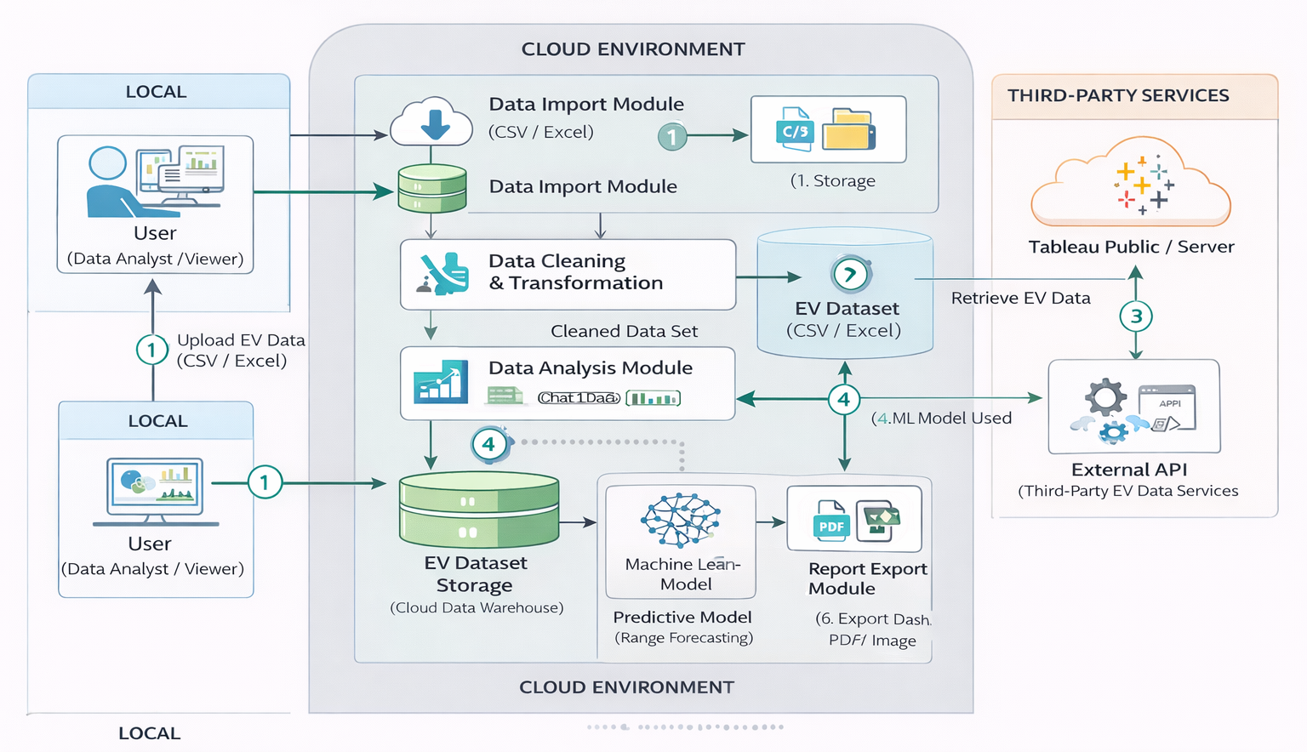
Table-1 : Components & Technologies:
S.No | Component | Description | Technology
 | User Interface | Interactive dashboard to visualize EV charge level, battery status, and driving range | HTML, CSS, Bootstrap, JavaScript
 | Application Logic-1 | Processes EV data such as battery percentage, charging time, and range calculations | Python
 | Application Logic-2 | Handles visualization and graphical representation of charge vs range data | Matplotlib / Plotly
 | Application Logic-3 | Performs data analysis and simulation of EV performance metrics | Pandas, NumPy
 | Database | Stores EV specifications, battery capacity, and test datasets | CSV / JSON files
 | Cloud Database | Optional cloud data storage for large datasets | MongoDB
 | File Storage | Stores datasets, charts, and static resources | Local File System
 | External API-1 | Retrieves EV specifications or real-time charging station data | Open Charge Map API
 | External API-2 | Map visualization for charging stations | Google Maps API
 | Machine Learning Model | Predicts driving range based on battery level and usage conditions | Scikit-learn
 | Infrastructure (Server / Cloud) | Application deployment and hosting | Local Server

Table-2: Application Characteristics:
S.No | Characteristics | Description | Technology
 | Open-Source Frameworks | Frameworks used for backend and visualization | Bootstrap
 | Security Implementations | Data validation and secure API handling | Input validation
 | Scalable Architecture | Modular design separating UI, processing, and data layers | 3-Tier Architecture
 | Availability | Accessible via web browser for analysis and visualization | Web-based dashboard
 | Performance | Efficient handling of EV datasets and real-time visualization | Pandas optimization, Lightweight backend

